|  |  |
| --- | --- |
| **EX.NO: 04** | **DEMONSTRATE HOW TO PROVIDE SECURE DATA STORAGE, SECURE DATA TRANSMISSION AND FOR CREATING DIGITAL SIGNATURES (GNUPG).** |
| **DATE:** |

**Aim:**

To demonstrate how to provide secure data storage, secure data transmission and for creating digital signatures (GnuPG).

**Procedure:**

**Step 1:** Install the Net Stumbler.

**Step 2:** To generate a public/private key pair, run the following command:

$gpg --gen-key

**Step 3:** To check what's on your public keyring, run

$gpg --list-keys

Or

$gpg --list-public-keys

**Step 4:** To view the keys on your private (secret) keyring, run:

$gpg –list-secret-keys

1. **GPG Encryption Guide – Symmetric Encryption**

**Step 5:** To see a list of available ciphers, run

$gpg –version

Cypher: 3DES, CAST5, BLOWFISH, AES, AES192, AES256, TWOFISH, CAMELLIA128,

CAMELLIA192, CAMELLIA256

**AES256 Cipher**

**Step 6:** To encrypt data using 256 bit AES, use the --cipher-algo AES256 option. For example to encrypt a file called file.txt using this cipher, use:

$gpg --symmetric --cipher-algo AES256 file.txt

You can call the resulting file whatever you like by using the -o (or --output) option.

$gpg -o filename --symmetric --cipher-algo AES256 file.txt

**Step 7:** To decrypt, use the command:

$gpg -d file.txt.gpg

**Digitally Signing Symmetrically Encrypted Data**

**Step 8:** To sign and symmetrically encrypt file.txt using AES256, use the --sign option like this:

$gpg --sign --symmetric --cipher-algo AES256 file.txt

Then to verify the signature and decrypt, you would use:

$gpg -d file.txt.gpg

(The -d option will automatically try to verify any signature and also decrypt).

1. **GPG Encryption Guide - Asymmetric Encryption**

**Step 9:** Ensure that you have the public key for the person you want to encrypt data for.

You can double check this by using the command:

$gpg --list-keys

**Step 10:** To encrypt a file you can use the -e (or --encrypt) option along with the -r (or --recipient) option, as shown below:

$gpg -e -r key-id|name filename

So if someone wanted to encrypt a file called file.txt for us here at Tutonics, they could use the user name "Tutonics":

$gpg -e -r Tutonics file.txt

or use the key-id "EE74D48D",

$gpg -e -r EE74D48D file.txt

**Step 11:** To decrypt file.txt.gpg from above, the recipient (and owner of the private key) would execute this command:

$gpg -o file.txt -d file.txt.gpg

1. **GPG Encryption Guide - Digital Signatures**

**Using A Clear Sign Digital Signature**

**Step 12:** To sign file.txt using this method you would use:

$gpg --clearsign file.txt

Note that by default the name of the signed file has an appended .asc, you can control the name using the -o (or --output) option, eg:

$gpg --output filename --clearsign file.txt

On the receiving side, the recipient can verify the signature (provided they have the sender's public key on their keyring).

$gpg --verify file.txt.asc

**Using A Binary Digital Signature**

**Step 13:** To sign data normally, use the -s (or --sign) option. Using the same file.txt that we used above, we can sign like so:

$gpg --sign file.txt

This will produce the file file.txt.gpg. Someone with the sender's public key can verify this in the exact same way as a clear sign signature by using the --verify option:

$gpg --verify file.txt.gpg

**Using A Digital Signature With Asymmetrically Encrypted Data**

**Step 14:** The command below signs and encrypts for recipient Tutonics :

$gpg -o file.enc -s -e -r Tutonics file.txt

In order to verify without decrypting, the recipient can run:

$gpg --verify file.enc

If the recipient does not have the sender's public key on their keyring for verification, the decryption will still work as usual, but following message will be displayed:

gpg: Can't check signature: public key not found

**Using A Detached Digital Signature**

**Step 15:** If you wish to leave the original file as-is and create a separate binary signature file, you can use the --detach-sign option. For example, using file.txt run:

$gpg --detach-sign file.txt

This will produce the file file.txt.sig, which is made available to others along with the original data (file.txt in this case). To verify the authenticity of file.txt, you would run the following command (which assumes file.txt is in the current directory along with file.txt.sig):

$gpg --verify file.txt.sig

**Result:**

Thus, the demonstrate to provide secure data storage, secure data transmission and for creating digital signatures (GnuPG).

**VIVA QUESTIONS:**

1. **What are Digital certificates?**

Digital certificates are digital documents attesting to the binding of a public key to an individual or other entity. They allow verification of the claim that a given public key does in fact belong to a given individual. Certificates help prevent someone from using a phony key to impersonate someone else.

1. **What is Secure Sockets Layer (SSL)?**

The Secure Sockets Layer (SSL) is a computer networking protocol that manages server authentication, client authentication and encrypted communication between servers and clients.

1. **What is the technology available to ensure data privacy and integrity during transmission?**

1. Controlling Access within the Network

2. Encrypting Data for Network Transmission

3. Secure Sockets Layer (SSL) Protocol

4. Firewall

4. **What are the services provided by digital certificates?**

Digital certificate provide authentication, nonrepudiation and integrity services.

|  |  |
| --- | --- |
| **EX.NO: 05** | **SETUP A HONEY POT AND MONITOR THE HONEYPOT ON NETWORK (KF SENSOR)** |
| **DATE:** |

**Aim:**

To setup a honey pot and monitor the honeypot on network (KF Sensor).

**Procedure:**

**Step 1:** Install a honey pot.

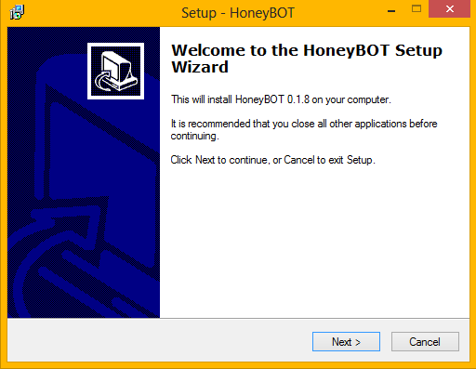

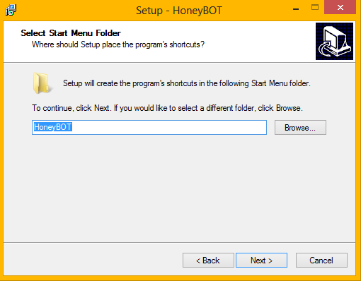

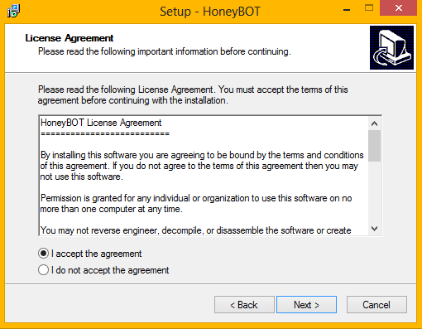

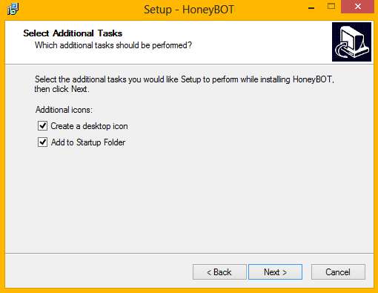

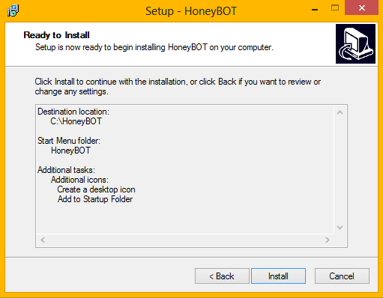

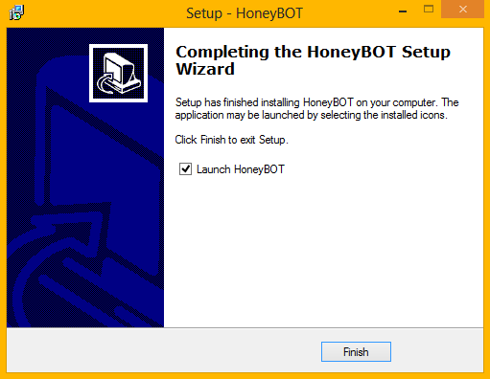

**Step 2:** Monitoring the honey bot using KF sensor.

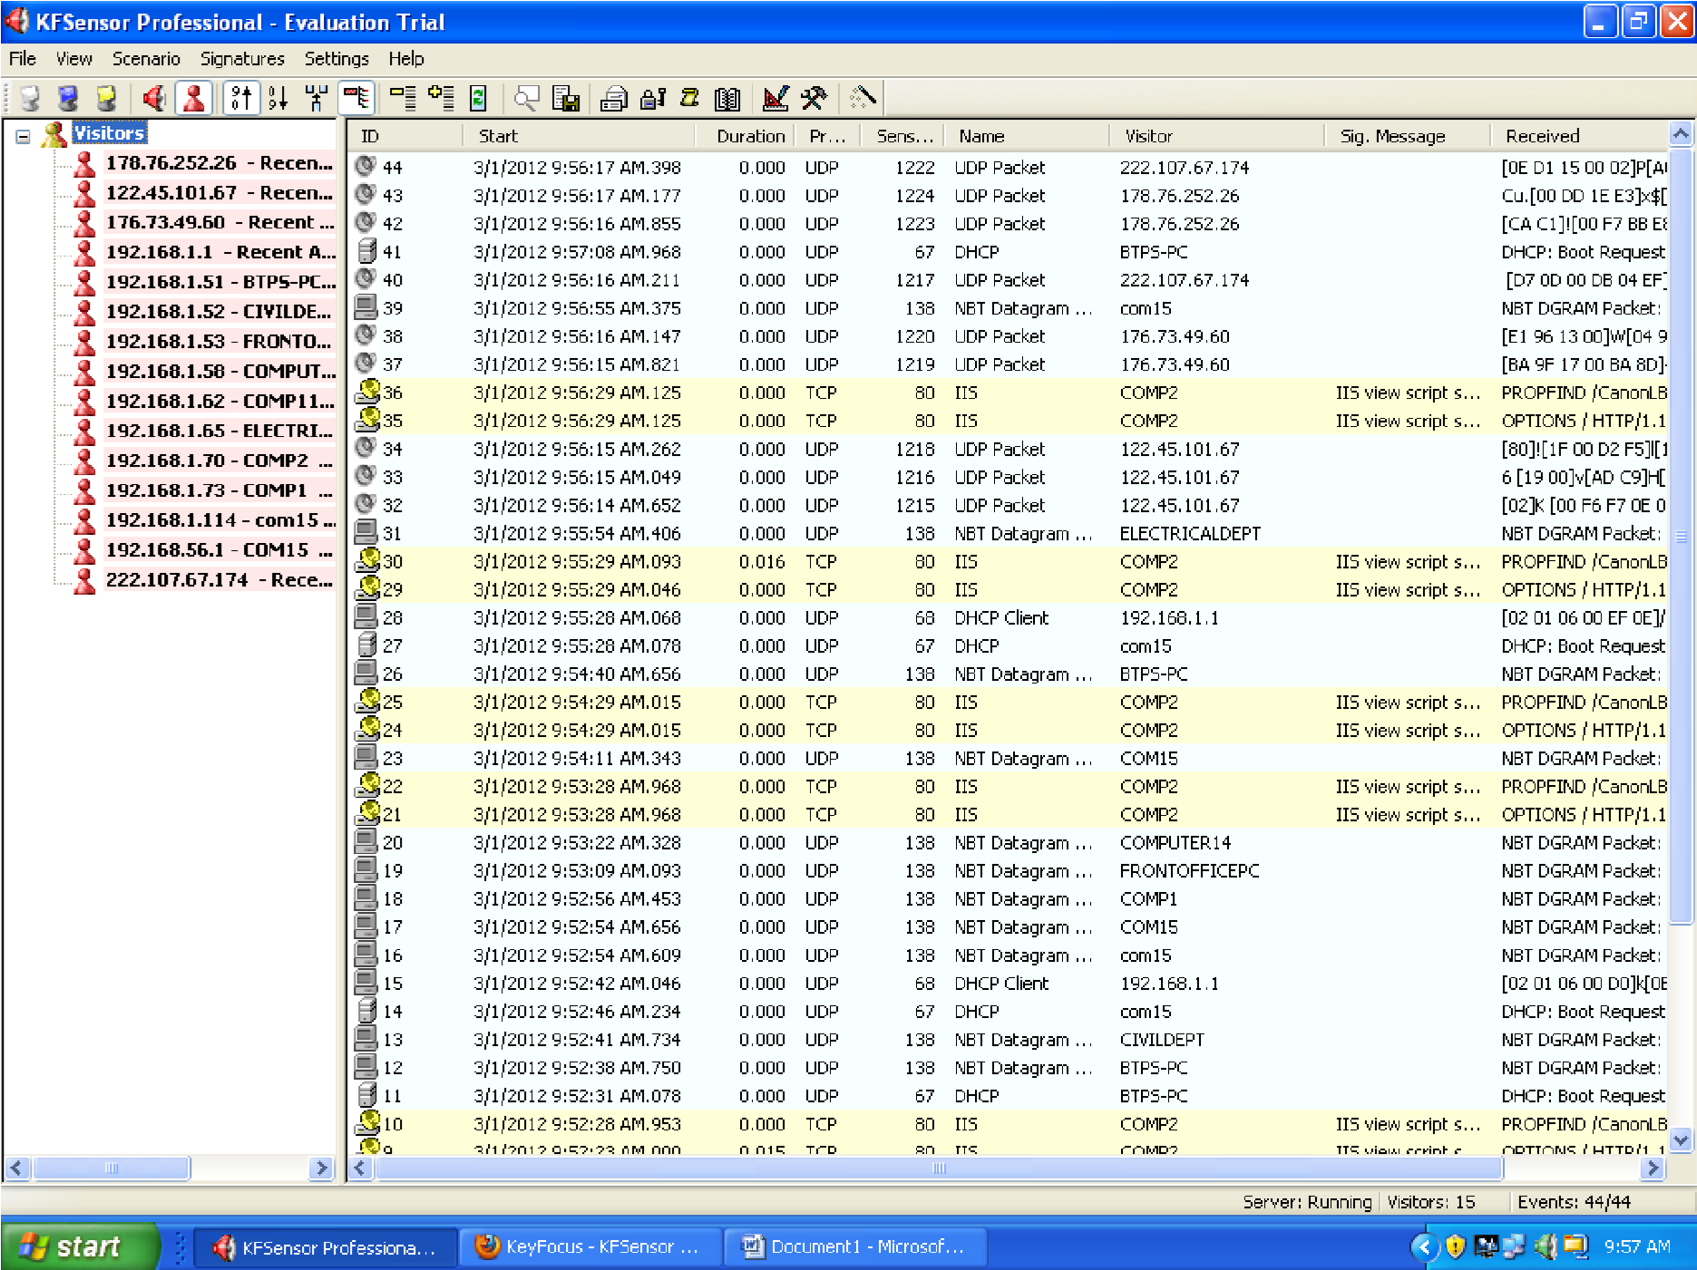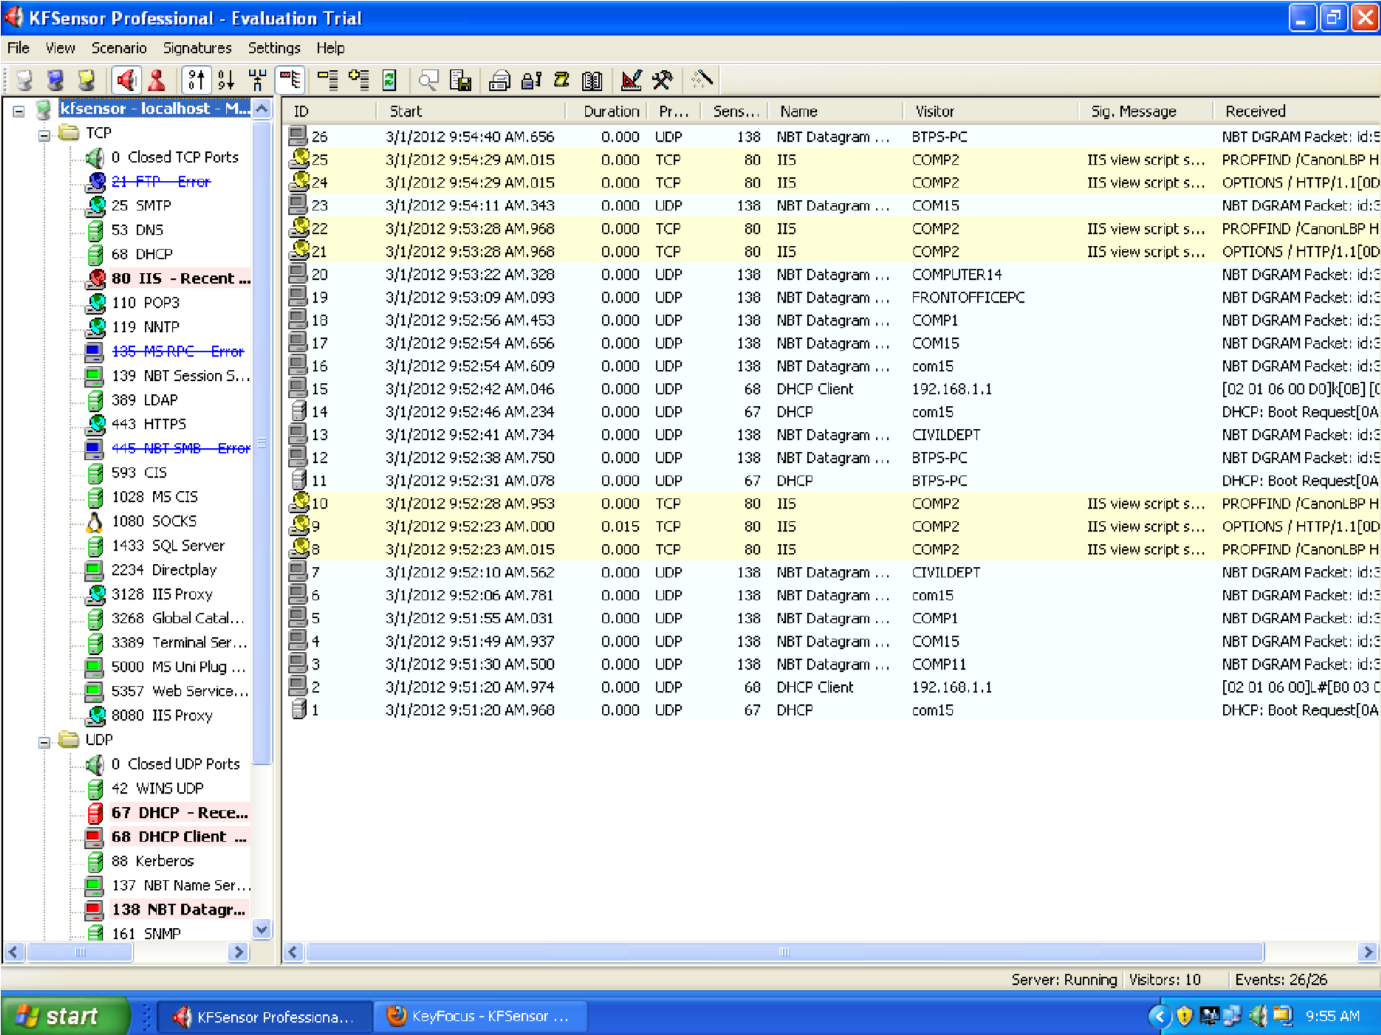

**Result:**

Thus, the setup a honey pot and monitor the honeypot on network (KF Sensor) has been executed and verified successfully.

**VIVA QUESTIONS:**

1. **What do you understand by honeypot on network?**

A honeypot is a device placed on a computer network specifically designed to capture malicious network traffic. The logging capability of a honeypot is far greater than any other network security tool and captures raw packet level data even including the keystrokes and mistakes made by hackers. The captured information is highly valuable as it contains only malicious traffic with little to no false positives. Honeypots are becoming one of the leading security tools used to monitor the latest tricks and exploits of hackers by recording their every move so that the security community can more quickly respond to new exploits.

1. **How is honeypot works?**

Honeypot works by opening over 1000 UDP and TCP listening sockets on your computer and these sockets are designed to mimic vulnerable services. When an attacker connects to these services they are fooled into thinking they are attacking a real server. The honeypot safely captures all communications with the attacker and logs these results for future analysis. Should an attacker attempt an exploit or upload a rootkit or trojan to the server the honeypot environment will safely store these files on your computer for analysis and submission to antivirus vendors.

1. **How will you install honey pots?**

* Honeypot can be downloaded from the web site at: http://www.atomicsoftwaresolutions.com/honeybot.php
* After clicking the download link save Honeypot_010.exe to a location on your hard drive.
* Double click the Honeypot_010.exe installation file to begin the setup process.
* Follow the prompts in the setup process. The default installation folder for setup is c:\honeybot\
* Setup will create a shortcut in the Start Menu folder and an option is available to create a desktop icon
* Now you can launch Honeypot using the programs shortcut icon
* Click on the blue play button to start the Honeypot listening engine
* Using a Web Browser try to access various network systems by providing their IP addresses.

1. **What are log files?**

All log files are saved by default to c:\honeybot\logs folder. Log files store information relating to the hits on the system and also store all data received and sent to the attacking computer.

1. **How will you uninstall honeypots?**

Click on the red stop button to shut down all listening services and terminate all existing open sockets. Uninstalling Honeypot Click the Uninstall Honeypot icon in the programs start menu to uninstall Honeypot and follow the prompts.

|  |  |
| --- | --- |
| **EX No: 06** | **INSTALLATION OF ROOTKITS AND STUDY ABOUT**  **THE VARIETY OF OPTIONS** |
| **DATE:** |

**Aim:**

To installation of rootkits and study about the variety of options.

**Procedure:**

**Step 1:** Install a Net Stumbler.

**Step 2:** When GMER is opened, the list of Rootkit/Malware will be shown

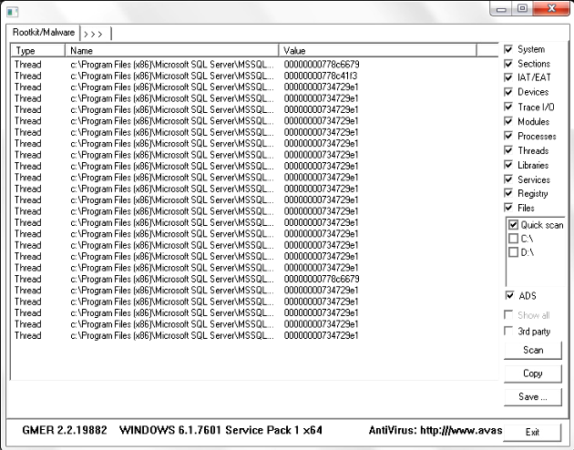

**Step 3:** The main cause of malware is Microsoft SQL Server.



**Step 4:** Move to the “Processes” tab menu and select “sqlservr.exe”.



**Step 5:** Kill the process “sqlservr.exe” by clicking yes and exit the rootkit.



**Step 6:** Open the GMER rootkit. In the “Processes” tab menu, select the ‘javaw.exe’

processes.



**Step 7:** Kill the selected processes.



**Step 8:** After killing the processes, “virus.dll” file will not grow. The killed processes will not

present in the tab menu.



**Result:**

Thus, the installation of rootkits and study about the variety of options has been studied and verified successfully.

**VIVA QUESTIONS:**

1. **What is Rootkit?**

The term Rootkit originally referred to a collection of tools used to gain administrative access on UNIX operating systems. The collection of tools often included well-known system monitoring tools that were modified to hide the actions of an unauthorized user. An unauthorized user would replace the existing tools on the system with the modified versions preventing authorized users from discovering the security breach. Rootkit - “A tool used to protect backdoors and other tools from detection by administrators”

1. **What are called Rootkits in Windows?**

They refers to programs that use system hooking or modification to hide files, processes, registry keys, and other objects in order to hide programs and behaviours. In particular, Windows rootkits do not necessarily include any functionality to gain administrative privileges. In fact, many Windows rootkits require administrative privileges to even function.

1. **What are the basic classes of Rootkits?**

Two basic classes of Windows rootkits: kernel mode rootkits & user mode rootkits.

1. **Why Rootkits are used?**

Rootkits are used by criminals for a variety of purposes, usually to turn a computer into part of a botnet, which can then, in turn, go on to infect other computers or send spam email messages. The rootkit owner can install key loggers to capture user-entered passwords for online banking and similar activities, or steal the user’s personal details to use for identity fraud.

1. **How Rootkits stay undetected?**

Many rootkits infect the boot sectors of the computer’s hard disk, allowing them to load before the computers operating system. The rootkit then patches the operating system and changes common functions to hide its existence. For example, the root kit could intercept calls for a list of files in a directory, removing its own file names before showing the results to the user, so it would appear as if the directory is clean.

1. **What are the Rootkit capabilities?**

Current Rootkit Capabilities: Rootkits Hide processes, Hide files, Hide registry entries, Hide services, Completely bypass personal firewalls, Undetectable by antivirus, Remotely undetectable, Covert channels - undetectable on the network, Defeat cryptographic hash checking, Install silently, All capabilities ever used by viruses or worms.

|  |  |
| --- | --- |
| **EX.NO: 07** | **PERFORM WIRELESS AUDIT ON AN ACCESS POINT OR A ROUTER AND DECRYPT**  **WEP AND WPA. ( NETSTUMBLER)** |
| **DATE:** |

**Aim:**

To perform wireless audit on an access point or a router and decrypt WEP and WPA. (Net Stumbler).

**Procedure:**

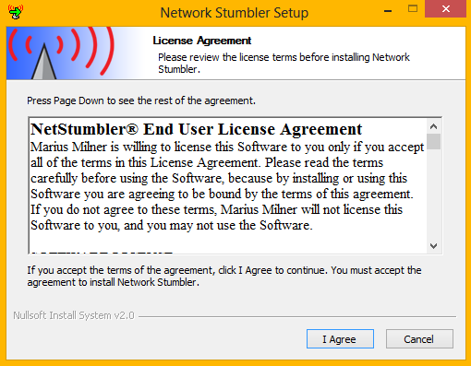 **Step 1:** Install a Net Stumbler.

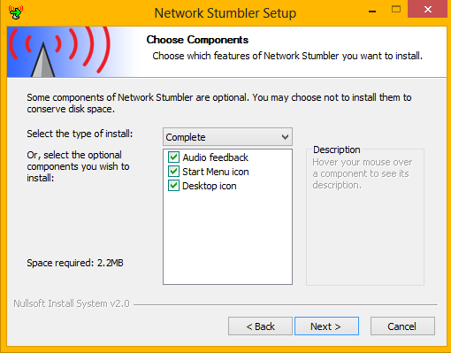

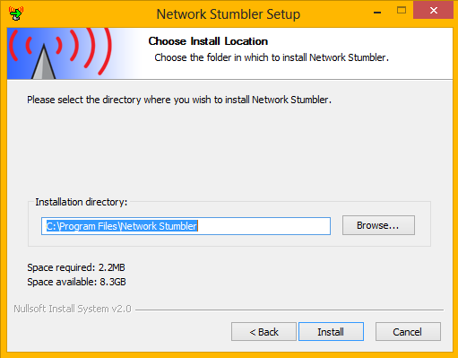

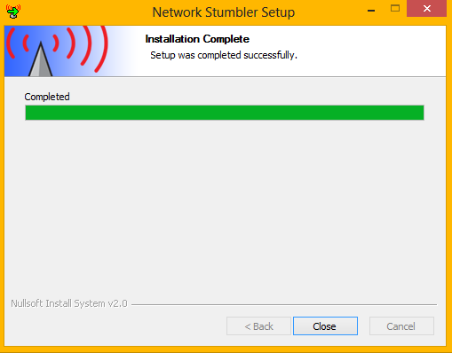

**Step 2**: Vi Stumbler Output.

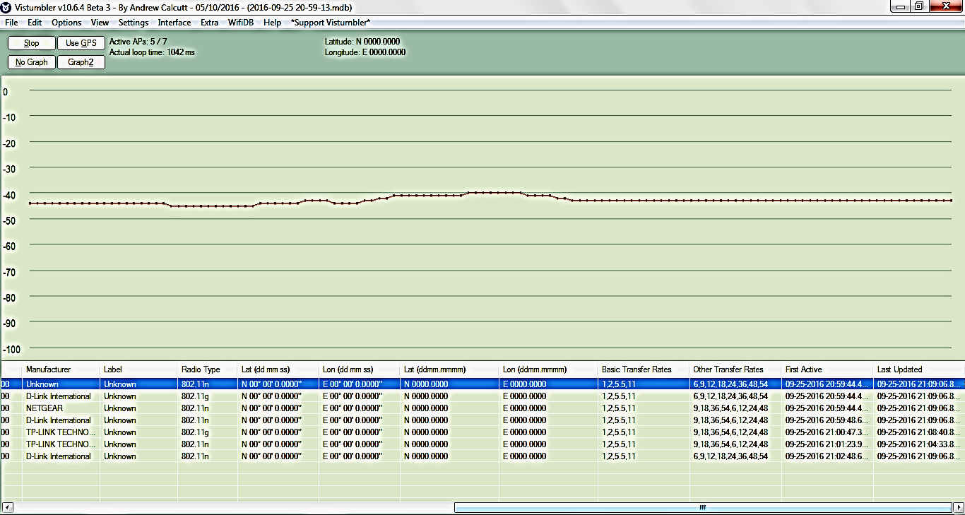

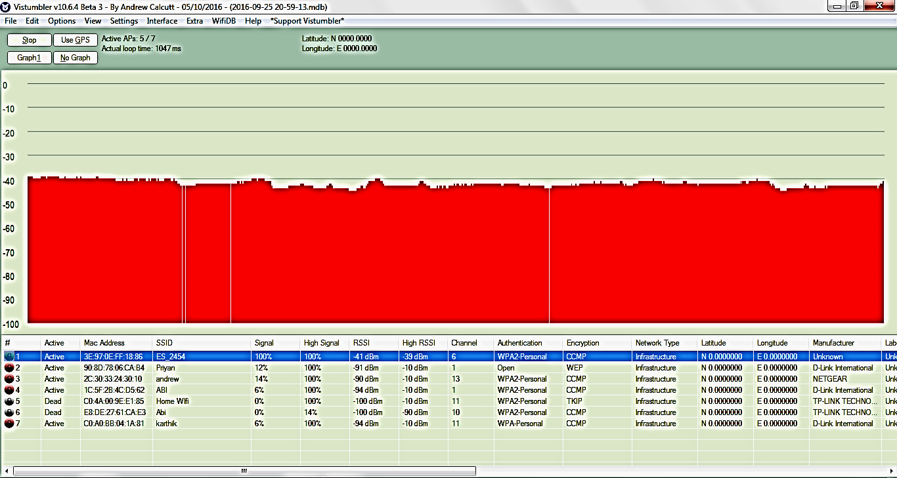

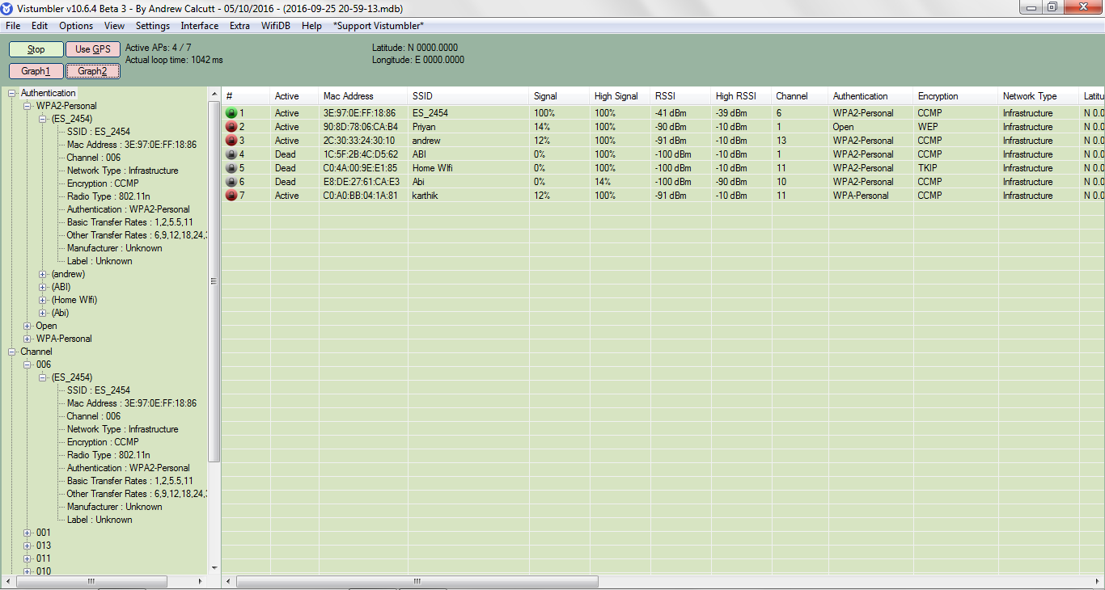

**Step 3:** Wi-Fi Inspector Output.

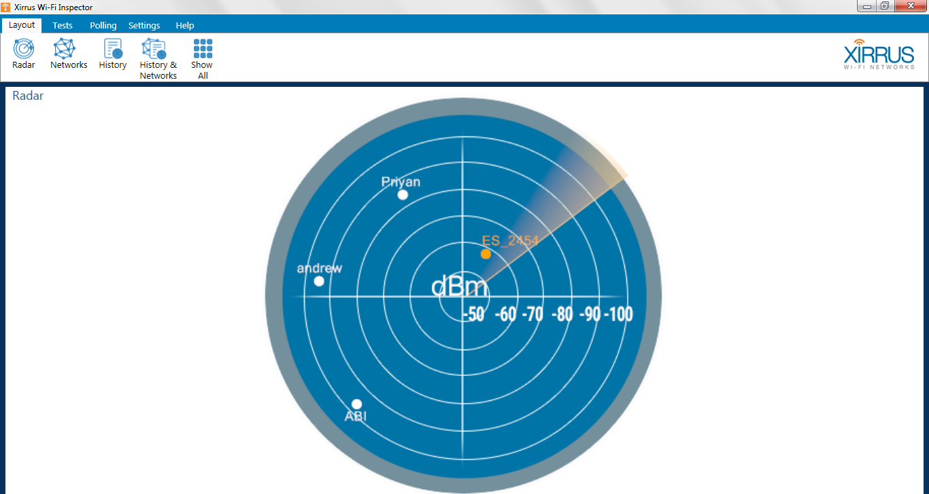

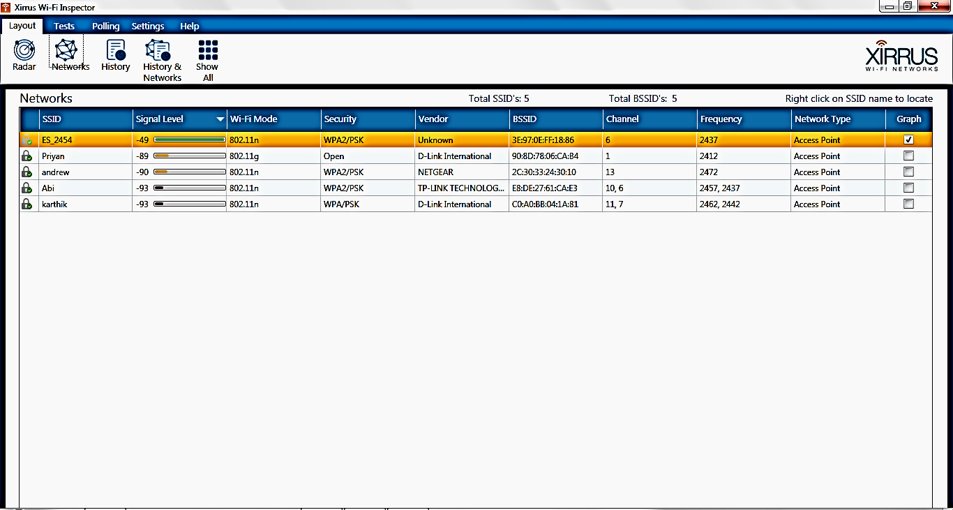

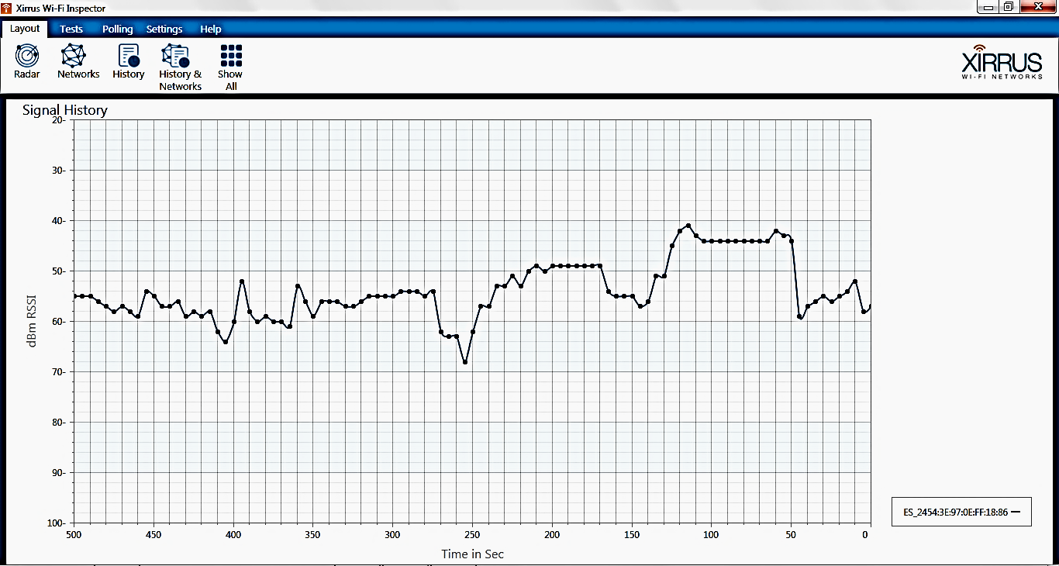

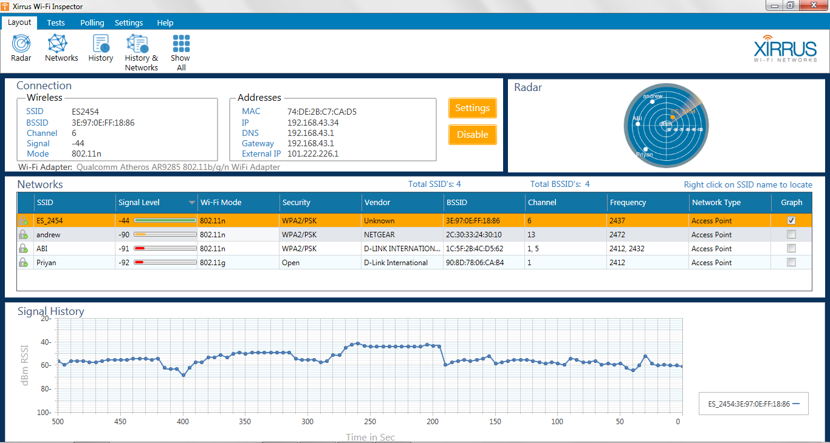

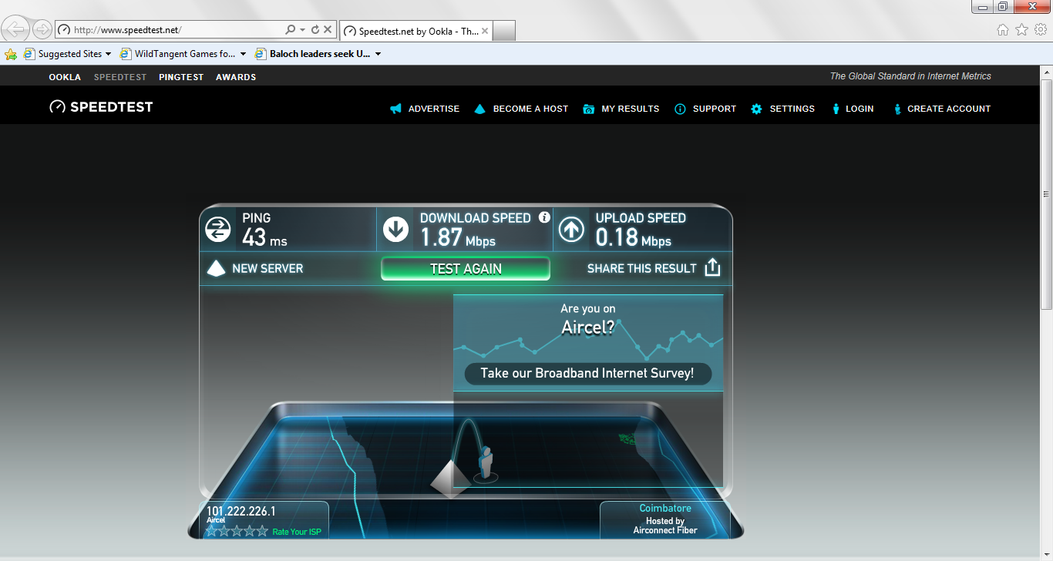

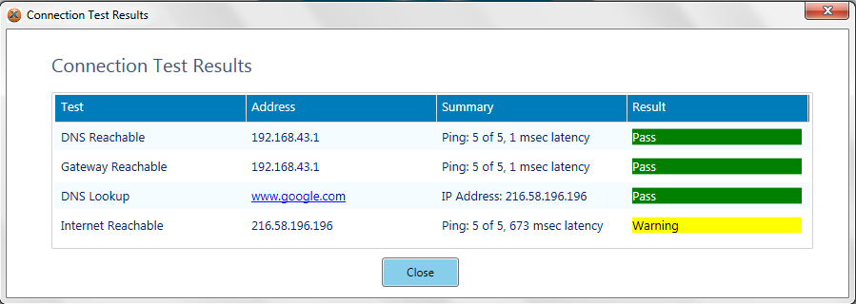

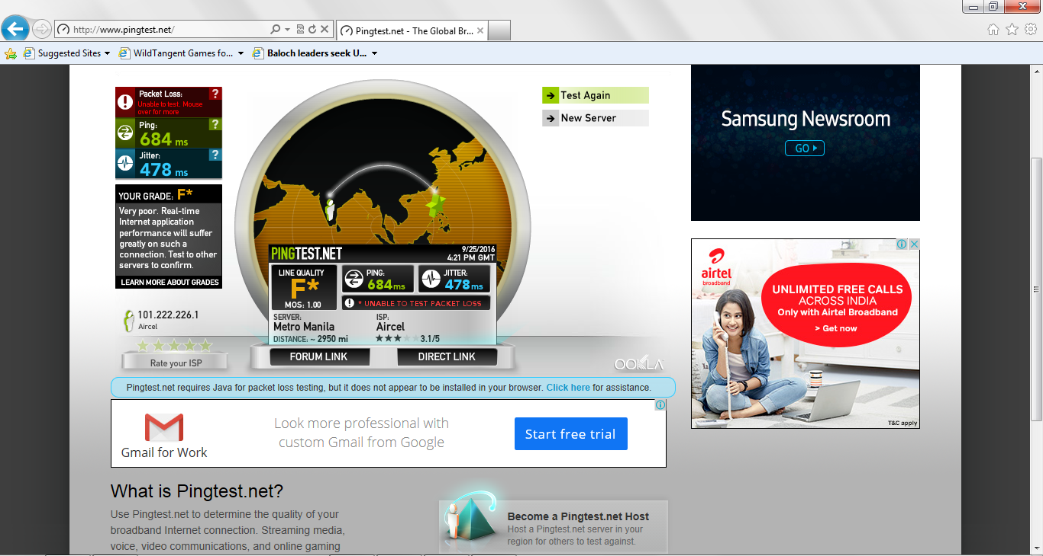

**Result:**

Thus, theperform wireless audit on an access point or a router and decrypt WEP and WPA.

( Net Stumbler) has been executed and verified successfully.

**VIVA QUESTIONS:**

1. **What is WAP?**

The Net Stumbler provides following details of WLAN (wireless LAN): MAC : The Media Access Control or MAC address is a unique code assigned to networking hardware, in this case the MAC address is referring to the address assigned to the Wireless AP (WAP). So beside the green bubble we see the 12 character MAC address for that AP.

1. **What is BSSID?**

The text contains the BSSID (Basic Service Set Identifier) for wireless devices. The icon shows the signal strength as reported in the last scan: Grey means the item was not detected, or a coloured icon ranging from red to green reports the signal strength. A lock appears in the icon if encryption is enabled on the network. For devices on a wired network segment, the icon shows a T-shaped network cable and the MAC address is displayed.

1. **What is SSID?**

SSID (Service Set Identifier): The reported SSID. This may be blank for access points that report their existence but not their SSID. For wired network items, the SSID is assumed to be the SSID that was associated when the item was discovered.

1. **What is Latitude, Longitude Distance?**

If you are using a GPS receiver, this indicates the estimated position of the object. This position is currently the location where the strongest signal was seen, which is never the actual location. Distance is measured from your current position to the object's estimated position.

1. **What is WEP?**

Access Points (APs) that do have encryption enabled. One of the flaws with the latest version of Net Stumbler is that all enabled encryption is displayed as WEP. Decrypt 802.11 Wireshark can decrypt WEP and WPA/WPA2 in pre-shared (or personal) mode. WPA/WPA2 enterprise mode decryption is not yet supported. You can add decryption keys using Wireshark's 802.11 preferences or by using the wireless toolbar. Up to 64 keys are supported.

|  |  |
| --- | --- |
| **EX.NO: 08** | **DEMONSTRATE INTRUSION DETECTION SYSTEM (IDS) USING ANY TOOL**  **(SNORT OR ANY OTHER S/W)** |
| **DATE:** |

**Aim:**

To demonstrate intrusion detection system (ids) using any tool (snort or any other s/w).

**Procedure:**

**Step 1:** Install the snort.

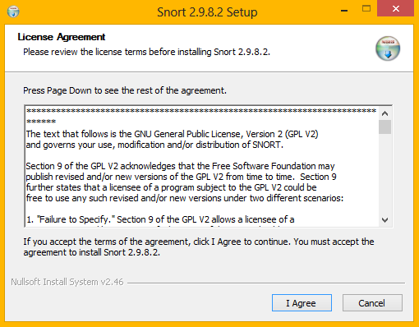

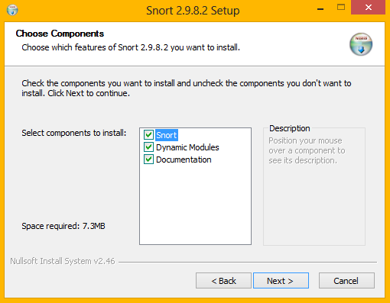

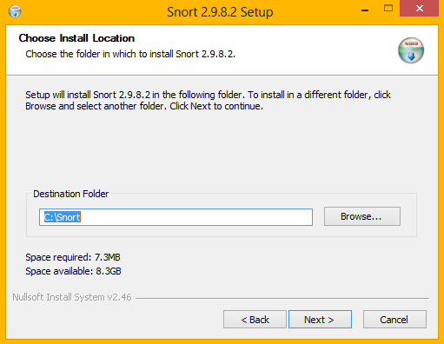

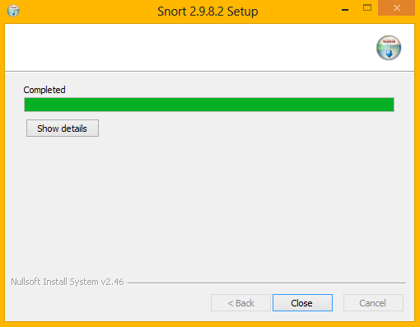

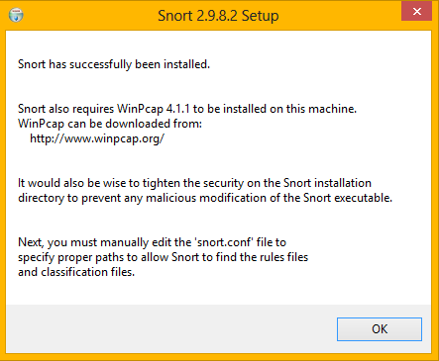

S**tep 2:** Extract downloaded Rules file: snortrules-snapshot-(number).tar.gz

Copy all files from the "rules" directory of the extracted folder and paste them into

"C:\Snort\rules"directory.

**Step 3:** Copy "snort.conf" file from the "etc" directory of the extracted folder and paste it into

"C:\Snort\etc" directory. Overwrite existing file if there is any

**Step 4:** To execute snort in sniffer mode use following command:

snort -dev -i

-i indicate interface number.

-dev is used to run snort to capture packets.

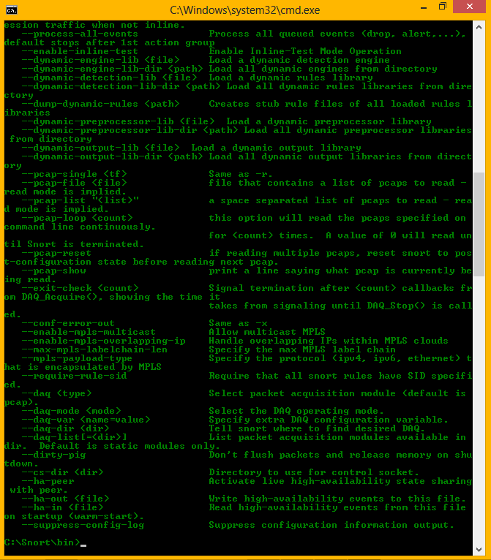

**Step 5:** To execute snort in sniffer mode use following command:

snort -w

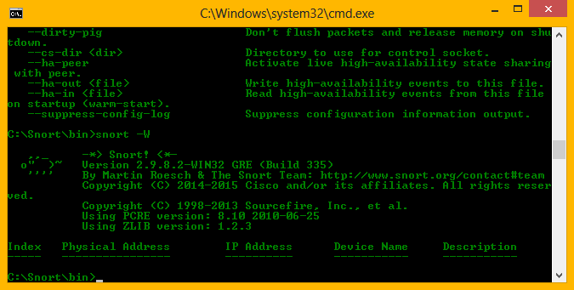

**Step 6:** Set up network address we want to protect in snort.conf file. To do that look for

"HOME_NET" and add your IP address. var HOME_NET 10.1.1.17/8

**Step 7:** You can also set addresses or DNS_SERVERS, if you have any. otherwise go to the next step.

**Step 8:** Change RULE_PATH variable with the path of rules directory. var RULE_PATH c:\snort\rules

**Step 9:** Change the path of all libraries with the name and path on your system. or change path of snort dynamic pre-processor variable. sor file C:\Snort\lib\snort_dynamiccpreprocessor\sf_dcerpc.dll

You need to do this to all library files in the "C:\Snort\lib" directory. The old path might be something like: "/usr/local/lib/...". you need to replace that path with you system path.

**Step 10:** Change path of the "dynamic engine" variable value in the "snort.conf" file with the path of your system. Such as:

Dynamic engine C:\Snort\lib\snort_dynamicengine\sf_engine.dll

**Step 11:** Add complete path for "include classification.config" and "include reference.config" files. Include c:\snort\etc\classification.config

Include c:\snort\etc\reference.config

**Step 12:** Remove the comment on the line to allow ICMP rules, if it is alredy commented.

Include $RULE_PATH/icmp.rules

**Step 13:** Similar, remove the comment of ICMP-info rules comment, if it is already commented. Include $RULE_PATH/icmp-info.rules

**Step 14:**To add log file to store alerts generated by snort, search for "output log" test and add following line:

output alert_fast: snort-alerts.ids

**Step 15:** Comment whitelist $WHITE_LIST_PATH/white_list.rules and blacklist $BLACK_LIST_PAT H/black_list.rules lines. Also ensure that you add change the line above

$WHITE_LIST_PATH Change nested_ip inner , \ to nested_ip inner #, \

**Step 16:** Comment following lines:

#preprocessor normalize_ip4

#preprocessor normalize_tcp: ips ecn stream

#preprocessor normalize_icmp4

#preprocessor normalize_ip6

#preprocessor normalize_icmp6

**Step 17:** Save the "snort.conf" file and close it.

**Step 18:** Go to the "C:\Snort\log" directory and create a file: snort-alerts.ids

**Step 19:** To start snort in IDS mode, run following command:

snort -c c:\snort\etc\snort.conf -l c:\snort\log -i 2

Above command will generate log file that will not be readable without using a tool. To read it use following command:

C:\Snort\Bin\> snort -r ..\log\log-filename

To generate Log files in ASCII mode use following command while running snort in IDS mode:

snort -A console -i2 -c c:\Snort\etc\snort.conf -l c:\Snort\log -K ascii

**Step 20:** Scan the computer running snort from another computer using PING or launch attack. Then check snort-alerts.ids file the log folder.

**Result:**

Thus, the demonstrate intrusion detection system (ids) using any tool (snort or any other s/w) has been executed and verified successfully.

**VIVA QUESTIONS:**

1. **What is Intrusion Detection System (IDS)?**

With the development of network technologies and applications, network attacks are greatly increasing both in number and severity. As a key technique in network security domain, Intrusion Detection System (IDS) plays vital role of detecting various kinds of attacks and secures the networks. Main purpose of IDS is to find out intrusions among normal audit data and this can be considered as classification problem.

1. **What are the activities of IDS?**

Intrusion detection systems (IDS) are an effective security technology, which can detect, prevent and possibly react to the attack. It performs monitoring of target sources of activities, such as audit and network traffic data in computer or network systems, requiring security measures, and employs various techniques for providing security services.

1. **What is intrusion or intruder?**

Intrusion: Attempting to break into or misuse your system. Intruders may be from outside the network or legitimate users of the network. Intrusion can be a physical, system or remote intrusion. Intrusion Detection Systems look for attack signatures, which are specific patterns that usually indicate malicious or suspicious intent.

1. **What is Snort?**

Snort is an open source network intrusion prevention system, capable of performing real time traffic analysis and packet logging on IP networks. It can perform protocol analysis, content searching/matching, and can be used to detect a variety of attacks and probes, such as buffer overflows, stealth port scans, CGI attacks, SMB probes, OS fingerprinting attempts, and much more.

1. **What are the uses of Snort?**

Snort has three primary uses: It can be used as a straight packet sniffer like tcpdump, a packet logger (useful for network traffic debugging, etc.), or as a full blown network intrusion prevention system. The privacy of the Snort community is very important to source fire.

1. **What are the three modes of Snort?**

Snort can be configured to run in three modes: 1. Sniffer mode 2. Packet Logger model 3. Network Intrusion Detection System mode Sniffer mode: snort –v Print out the TCP/IP packets header on the screen. Packet Logger mode : snort –dev –l c:\log [create this directory in the C drive] and snort will automatically know to go into packet logger mode, it collects every packet it sees and places it in log directory. Network Intrusion Detection System mode : snort –d c:\log –h ipaddress/24 –c nort conf. This is a configuration file applies rule to each packet to decide it an action based upon the rule type in the file.

|  |  |
| --- | --- |
| **EX.NO: 05** | **FIND PROCEDURE TO RUN THE VIRTUAL MACHINE OF DIFFERENTCONFIGURATION. CHECK HOW MANY VIRTUAL MACHINES CAN BE UTILIZED AT PARTICULAR TIME.** |
| **DATE:** |

**OBJECTIVE:**

To understand the procedure to run the virtual machine of different configuration.

Check how many Virtual machines can be utilized at particular time.

**PROCEDURE:**

**Requirements**

1. [Minimal Installation of CentOS 7](https://www.tecmint.com/centos-7-installation/#_blank)
2. [Minimal Installation of RHEL 7](https://www.tecmint.com/redhat-enterprise-linux-7-installation/#_blank)

**Step 1:** Initial System Configurations Create a Centos virtual machine in oracle virtual box.

**1.** Before you begin preparing the node in order to deploy your own virtual cloud infrastructure, first login with root account and assure that the system is up to date.

**2.** Next, issue the ss -tulpn command to list all running services.

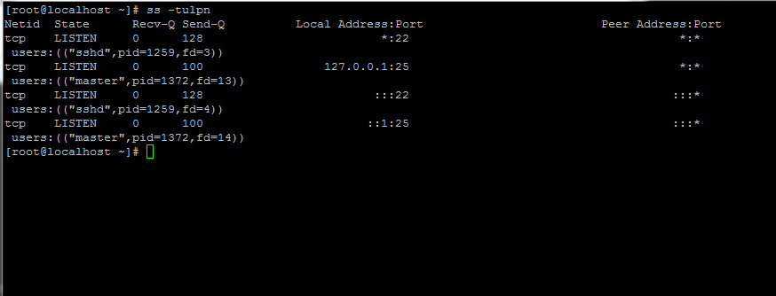 **# ss -tulpn**

**3.** Next, identify, [stop, disable and remove unneeded services](https://www.tecmint.com/remove-unwanted-services-in-centos-7/#_blank), mainly postfix, NetworkManager and firewalld. At the end the only daemon that would be running on your machine should be **sshd**.Stop and disable NetworkManager

**# sudo systemctl stop NetworkManager  
# sudo systemctl disable NetworkManager**

**Stop and disable firewalld**

**# sudo systemctl stop firewalld  
# sudo systemctl disable firewalld**

**4.** Completely disable Selinux policy on the machine by issuing the below commands. Also edit /etc/selinux/config file and set SELINUX line from **enforcing** to **disabled** as illustrated on the below screenshot.

**# setenforce 0**

**# getenforce**

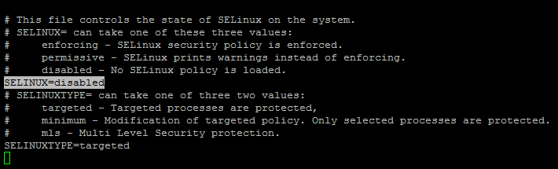# vi /etc/selinux/config

**5.** On the next step using the **hostnamectl** command to [set your Linux system hostname](https://www.tecmint.com/set-hostname-permanently-in-linux/#_blank). Replace the **FQDN** variable accordingly.

**# hostnamectl set-hostname cloud.centos.lan**

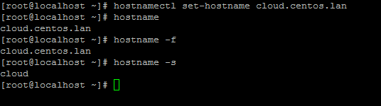

**6.** Finally, install ntpdate command in order to [synchronize time with a NTP server](https://www.tecmint.com/install-ntp-server-in-centos/#_blank) on your premises near your physical proximity.

**# yum install ntpdate**

### Step 2: Install OpenStack in CentOS and RHEL

**7.** **OpenStack** will be deployed on your Node with the help of **PackStack** package provided by **rdo** repository (**RPM Distribution of OpenStack**).

In order to enable **rdo** repositories on **RHEL 7** run the below command.

**# yum install https://www.rdoproject.org/repos/rdo-release.rpm**

On CentOS, the **Extras** repository provides the RPM that enables the OpenStack repository. Extra is enabled by default on CentOS 7, so you can simply install the RPM to set up the OpenStack repository. The current latest release is [Queens](https://releases.openstack.org/queens/index.html#_blank) – in case you want to install some older version, here is the list of available RDO [repos](https://repos.fedorapeople.org/repos/openstack/#_blank).

**# sudo yum install -y centos-release-openstack-queens**

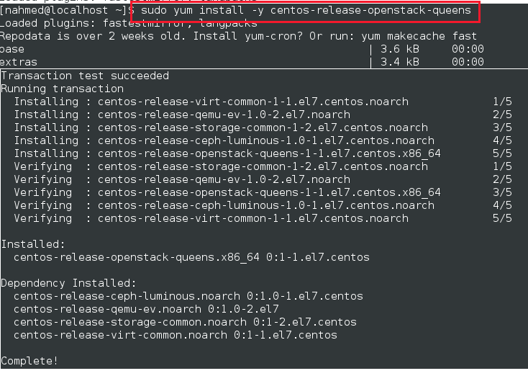

Update

**# sudo yum -y update**

Step 3 – Install Packstack

Packstack is an OpenStack setup utility, it uses Puppet modules to deploy, using [SSH](http://devopspy.com/linux/ssh-keygen/#_blank).

**# sudo yum install -y openstack-packstack**

Step 4 – Deploy and run OpenStack using Packstack

**# sudo packstack –allinone**

**OUTPUT:-**

Welcome to the Packstack setup utility The installation log file is available at: /var/tmp/packstack/20180502-004510-oUvzLC/openstack-setup.log

Packstack changed given value to required value /root/.ssh/id_rsa.pubInstalling:

Clean Up [ DONE ]

Discovering ip protocol version [ DONE ]

Setting up ssh keys [ DONE ]

Preparing servers [ DONE ]

Pre installing Puppet and discovering hosts' details [ DONE ]

Preparing pre-install entries [ DONE ]

Setting up CACERT [ DONE ]

Preparing AMQP entries [ DONE ]

Preparing MariaDB entries [ DONE ]

Fixing Keystone LDAP config parameters to be undef if empty[ DONE ]

Preparing Keystone entries [ DONE ]

Preparing Glance entries [ DONE ]

Checking if the Cinder server has a cinder-volumes vg[ DONE ]

Preparing Cinder entries [ DONE ]

Preparing Nova API entries [ DONE ]

Creating ssh keys for Nova migration [ DONE ]

Gathering ssh host keys for Nova migration [ DONE ]

Preparing Nova Compute entries [ DONE ]

Preparing Nova Scheduler entries [ DONE ]

Preparing Nova VNC Proxy entries [ DONE ]

Preparing OpenStack Network-related Nova entries [ DONE ]

Preparing Nova Common entries [ DONE ]

Preparing Neutron LBaaS Agent entries [ DONE ]

Preparing Neutron API entries [ DONE ]

Preparing Neutron L3 entries [ DONE ]

Preparing Neutron L2 Agent entries [ DONE ]

Preparing Neutron DHCP Agent entries [ DONE ]

Preparing Neutron Metering Agent entries [ DONE ]

Checking if NetworkManager is enabled and running [ DONE ]

Preparing OpenStack Client entries [ DONE ]

Preparing Horizon entries [ DONE ]

Preparing Swift builder entries [ DONE ]

Preparing Swift proxy entries [ DONE ]

Preparing Swift storage entries [ DONE ]

Preparing Gnocchi entries [ DONE ]

Preparing Redis entries [ DONE ]

Preparing Ceilometer entries [ DONE ]

Preparing Aodh entries [ DONE ]

Preparing Puppet manifests [ DONE ]

Copying Puppet modules and manifests [ DONE ]

Applying 192.168.169.130_controller.pp

192.168.169.130_controller.pp: [ DONE ]

Applying 192.168.169.130_network.pp

192.168.169.130_network.pp: [ DONE ]

Applying 192.168.169.130_compute.pp

192.168.169.130_compute.pp: [ DONE ]

Applying Puppet manifests [ DONE ]

Finalizing [ DONE ]

**** Installation completed successfully ******

Additional information:

* A new answer file was created in: /root/packstack-answers-20180502-004512.txt

* Time synchronization installation was skipped. Please note that unsynchronized time on server instances might be problem for some OpenStack components.

* Warning: NetworkManager is active on 192.168.169.130. OpenStack networking currently does not work on systems that have the Network Manager service enabled.

* File /root/keystonerc_admin has been created on OpenStack client host 192.168.169.130. To use the command line tools you need to source the file.

Please, find your login credentials stored in the keystonerc_admin in your home directory.

* The installation log file is available at: /var/tmp/packstack/20180502-004510-oUvzLC/openstack-setup.log

* The generated manifests are available at: /var/tmp/packstack/20180502-004510-oUvzLC/manifests

(no need for this, if you have executed the above command) If you don’t want to run packstack –allinone, rightaway as it installs everything (more then you may need). You can specify what to configure using answers file. First generate the answers file

**$ packstack --gen-answer-file=answer.txt**

**Step 5 – Verify**

**8.** Once the installation of **OpenStack** components is successfully completed, the installer will display a few lines with the local dashboard links for **OpenStack** and **Nagios** and the required credentials already configured above in order to login on both panels.

OpenStack Installation Completed.

The credentials are also stored under your home directory in **keystonerc_admin** file.

In order to access OpenStack web panel from a remote host in your LAN navigate to your machine IP Address or FQDN/dashboard via HTTPS protocol.

Due to the fact that you’re using a **Self-Signed Certificate** issued by an **untrusted Certificate Authority** an error should be displayed on your browser.

Accept the error and login to the dashboard with the user **admin** and the **password** set on **CONFIG_KEYSTONE_ADMIN_PW** parameter from answer file set above.

**#vi keystonerc_admin**

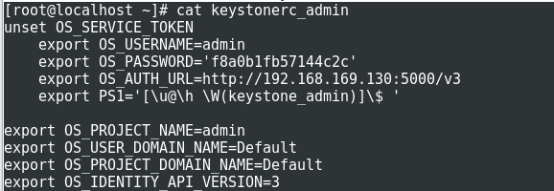

User id and password can be viewed

**User Name: admin**

**Password: 3fcee06c8d914e21**

**host id: https://192.168.1.40/dashboard**

The dashboard

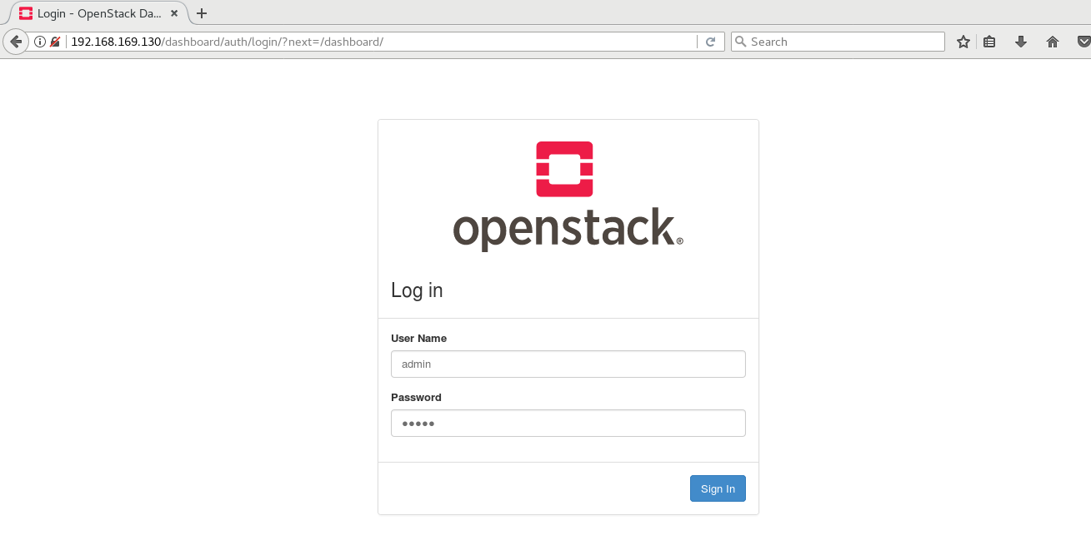

9. If for some reasons the installation process ends with an error regarding httpd service, open **/etc/httpd/conf.d/ssl.conf** file and make sure you comment the following line as illustrated below.

#Listen 443 https

Disable HTTPS SSL Port

Then restart Apache daemon to apply changes.

**# systemctl restart httpd.service**

Note: In case you still can’t browse Openstack web panel on port 443 restart the installation process from beginning with the same command issued for the initial deployment.

**# packstack --answer-file /root/13.04.16.conf**

**Sign-In**

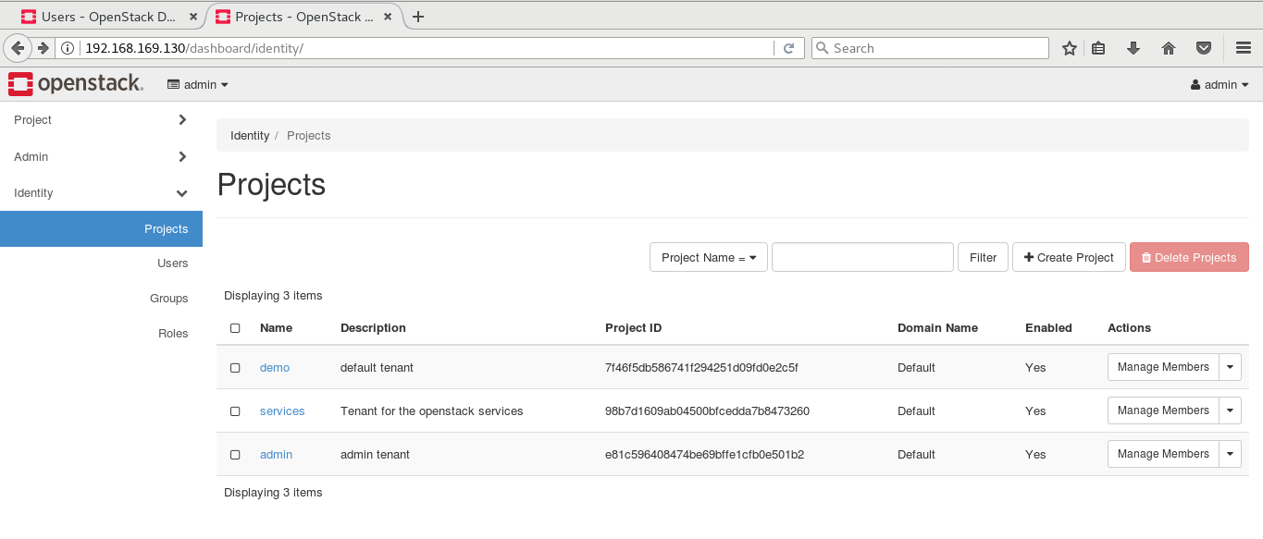

**RESULT:-**

Thus, to find produce for run the virtual machine of different configuration check how many virtual machines can be utilized at particular time using virtual machine is executed successfully.

|  |  |
| --- | --- |
| **EX.NO: 06** | **FIND PROCEDURE TO ATTACH VIRTUAL BLOCK TO THE VIRTUAL MACHINE AND CHECK WHETHER IT HOLDS THE DATA EVEN AFTER THE RELEASE OF THE VIRTUAL MACHINE.** |
| **DATE:** |

**OBJECTIVE:**

To write the procedure to attach virtual block to the virtual machine and check whether it holds the data even after the release of the virtual machine.

**PROCEDURE:**

* This experiment is to be performed through portal. Login to Openstack portal, in instances create virtual machine.
* In volumes create storage block of available capacity. Attach/mount the storage block volumes to virtual machines, unmount the volume and reattach it.
* Volumes are block storage devices that you attach to instances to enable persistent storage. You can attach a volume to a running instance or detach a volume and attach it to another instance at any time. You can also create a snapshot from or delete a volume. Only administrative users can create volume types.

**Create a volume**

1. Log in to the dashboard.

2. Select the appropriate project from the drop down menu at the top left.

3. On the Project tab, open the Compute tab and click Volumes category.

4. Click Create Volume.

In the dialog box that opens, enter or select the following values.

**Volume Name:** Specify a name for the volume.

**Description:** Optionally, provide a brief description for the volume.

**Volume Source**: Select one of the following options:

* **No source, empty volume:** Creates an empty volume. An empty volume does not contain a file system or a partition table.
* **Image:** If you choose this option, a new field for Use image as a source displays.

You can select the image from the list.

* **Volume:** If you choose this option, a new field for Use volume as a source displays. You can select the volume from the list. Options to use a snapshot or a volume as the source for a volume are displayed only if there are existing snapshots or volumes.

**Type:** Leave this field blank.

**Size (GB):** The size of the volume in gigabytes. (GB).

**Availability Zone:** Select the Availability Zone from the list. By default, this value is set

to the availability zone given by the cloud provider.

For some cases, it could be nova.

5. Click Create Volume.

The dashboard shows the volume on the Volumes tab.

On the Project tab, open the Compute tab and click the Volumes category.

6. Select the volume and click Manage Attachments.

7. Click Detach Volume and confirm your changes.

A message indicates whether the action was successful.

**Attach a volume to an instance**

After you create one or more volumes, you can attach them to instances. You can attach a volume to one instance at a time.

1. Log in to the dashboard.

2. Select the appropriate project from the drop down menu at the top left.

3. On the Project tab, open the Compute tab and click Volumes category.

4. Select the volume to add to an instance and click Manage Attachments.

5. In the Manage Volume Attachments dialog box, select an instance.

6. Enter the name of the device from which the volume is accessible by the instance.

**Note:** The actual device name might differ from the volume name because of hypervisor settings

7. Click Attach Volume.

The dashboard shows the instance to which the volume is now attached and the device name. You can view the status of a volume in the Volumes tab of the dashboard. The volume is either Available or In-Use.

Now you can log in to the instance and mount, format, and use the disk.

**Detach a volume from an instance**

1. Log in to the dashboard.

2. Select the appropriate project from the drop down menu at the top left.

3. On the Project tab, open the Compute tab and click Volumes category.

4. Select the check boxes for the volumes that you want to delete.

5. Click Delete Volumes and confirm your choice.

A message indicates whether the action was successful.

**Create a snapshot from a volume**

1. Log in to the dashboard.

2. Select the appropriate project from the drop down menu at the top left.

3. On the Project tab, open the Compute tab and click Volumes category.

4. Select a volume from which to create a snapshot.

5. In the Actions column, click Create Snapshot.

6. In the dialog box that opens, enter a snapshot name and a brief description.

7. Confirm your changes.

The dashboard shows the new volume snapshot in Volume Snapshots tab.

**Edit a volume**

1. Log in to the dashboard.

2. Select the appropriate project from the drop down menu at the top left.

3. On the Project tab, open the Compute tab and click Volumes category.

4. Select the volume that you want to edit.

5. In the Actions column, click Edit Volume.

6. In the Edit Volume dialog box, update the name and description of the volume.

7. Click Edit Volume.

**Note**: You can extend a volume by using the Extend Volume option available in the More dropdown list and entering the new value for volume size.

**Delete a volume**

When you delete an instance, the data in its attached volumes is not deleted.

1. Log in to the dashboard.

2. Select the appropriate project from the drop down menu at the top left.

3. On the Project tab, open the Compute tab and click Volumes category.

**RESULT:**

Thus, the procedure to attach virtual block to the virtual machine and check whether it holds the data even after the release of the virtual machine is executed successfully.

|  |  |
| --- | --- |
| **EX.NO: 08** | **CREATING OGSA(OPEN GRID SERVICE ARCHITECTURE) -COMPLIANT WEBSERVICE** |
| **DATE:** |

**OBJECTIVE:**

To develop a new OGSA (open grid service architecture) Compliant Webservice.

**PROCEDURE:**

**WCF**

WCF stands for Windows Communication Foundation. The elementary feature of WCF is interoperability. It is one of the latest technologies of Microsoft that is used to build service-oriented applications. Based on the concept of message-based communication, in which an HTTP request is represented uniformly, WCF makes it possible to have a unified API irrespective of diverse transport mechanisms.

A WCF application consists of three components −

1. WCF service,
2. WCF service host, and
3. WCF service client.

WCF platform is also known as the Service Model.

**Pre requisite:**

**WCF - Developers Tools**

Latest version of Microsoft Visual Studio 2010 is also a preferred tool for developing WCF service application.

**Selection of such a template leads to addition of files for the following purposes −**

* Service contract
* Service implementation
* Service configuration
* IIS − IIS stands for Internet Information Service. It offers a myriad of advantages using the HTTP protocol by a service. Here, it is not required to have the host code for activating the service code; instead, the service code gets activated automatically.

**WCF - Creating WCF Service**

Creating a WCF service is a simple task using Microsoft Visual Studio 2012. Given below is the step-by-step method for creating a WCF service along with all the requisite coding, to understand the concept in a better way.

Launch Visual Studio 2012.

**STEP 1:** Click on new project, then in Visual C# tab, select WCF option and save it as

**WCF Creating Service1**

A WCF service is created that performs basic arithmetic operations like addition, subtraction, multiplication, and division. The main code is in two different files – one interface and one class.

**STEP 2:**

**In PROJECT EXPLORER click Iservice1.cs and do the following changes:**

A WCF contains one or more interfaces and its implemented classes.

**Iservice1.cs**

using System;

using System.Collections.Generic;

using System.Linq;

using System.Runtime.Serialization;

using System.ServiceModel;

using System.Text;

namespace WcfServiceLibrary1

{

// NOTE: You can use the "Rename" command on the "Refactor" menu to

// change the interface name "IService1" in both code and config file

// together.

[ServiceContract]

public interface IService1

{

[OperationContract]

int sum(int num1, int num2);

[OperationContract]

int Subtract(int num1, int num2);

[OperationContract]

int Multiply(int num1, int num2);

[OperationContract]

int Divide(int num1, int num2);

}

// Use a data contract as illustrated in the sample below to add

// composite types to service operations.

[DataContract]

public class CompositeType {

bool boolValue = true;

String stringValue = "Hello ";

[DataMember]

public bool BoolValue {

get { return boolValue; }

set { boolValue = value; }

}

[DataMember]

public string StringValue {

get { return stringValue; }

set { stringValue = value; }

}

}

}

**STEP 3:** **In project explorer click Service1.cs and do the following changes:**

**Service1.cs**

The code behind its class is given below.

using System;

usingSystem.Collections.Generic;

usingSystem.Linq;

usingSystem.Runtime.Serialization;

usingSystem.ServiceModel;

usingSystem.Text;

namespace WcfServiceLibrary1 {

// NOTE: You can use the "Rename" command on the "Refactor" menu to

// change the class name "Service1" in both code and config file

// together.

publicclassService1 :IService1 {

// This Function Returns summation of two integer numbers

publicint sum(int num1, int num2) {

return num1 + num2;

}

// This function returns subtraction of two numbers.

// If num1 is smaller than number two then this function returns 0

Public int Subtract(int num1, int num2) {

if (num1 > num2) {

return num1 - num2;

}

else {

return 0;

}

}

// This function returns multiplication of two integer numbers.

Public int Multiply(int num1, int num2) {

return num1 * num2;

}

// This function returns integer value of two integer number.

// If num2 is 0 then this function returns 1.

Public int Divide(int num1, int num2) {

if (num2 != 0) {

return (num1 / num2);

} else {

return 1;

}

}

}

}

**STEP 4:** To run this service, click the Start button in Visual Studio.

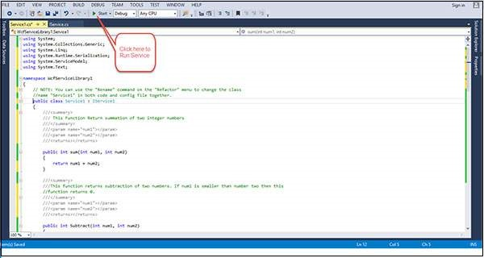

**STEP 5:** While we run this service, the following screen appears.

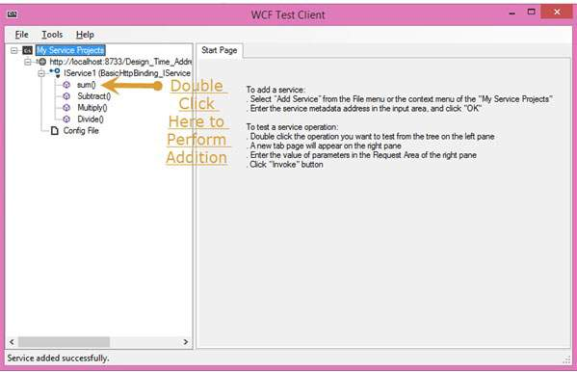

**STEP 6: Add ()**

On clicking the sum method, the following page opens. Here, you can enter any two integer numbers and click on the Invoke button. The service will return the summation of those two numbers.

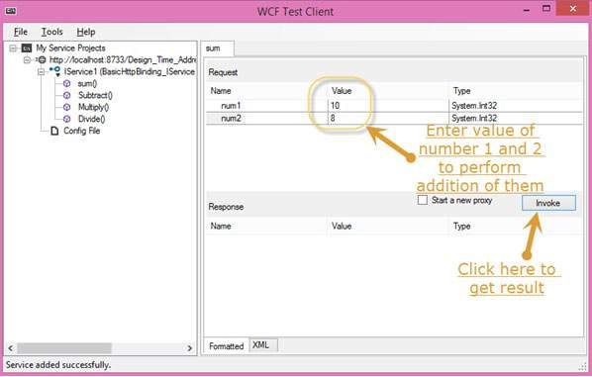

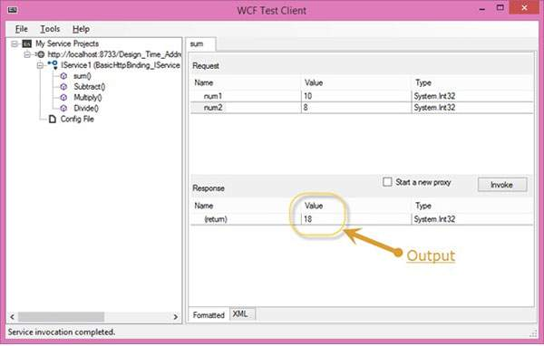

**Step 7: Subtract ()**

The following page appears on clicking the Subtract method. Enter the integer numbers, click the Invoke button, and get the output as shown here –

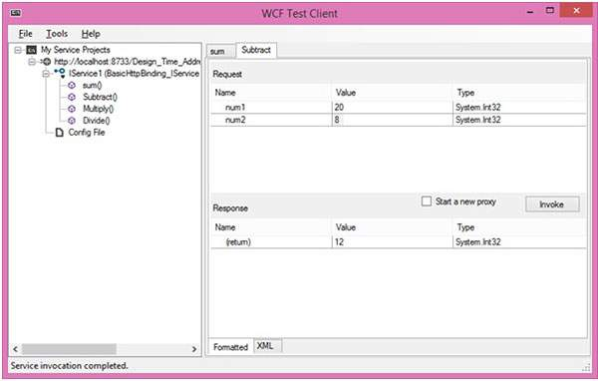

**Step 8: Multiply ()**

The following page appears on clicking the Multiply method. Enter the integer numbers, click the Invoke button, and get the output as shown here −

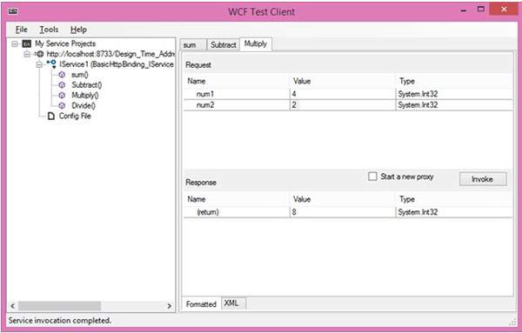

**Step 9: Divide ()**

The following page appears on clicking the Divide method. Enter the integer numbers, click the Invoke button, and get the output as shown here –

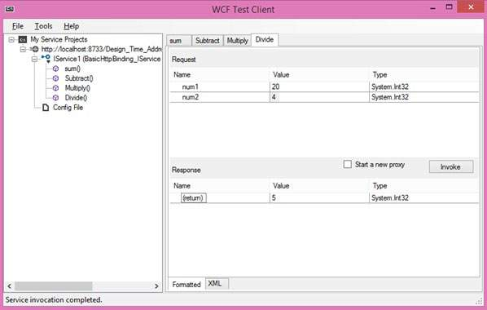

**Step 10**: Once the service is called, you can switch between them directly from here.

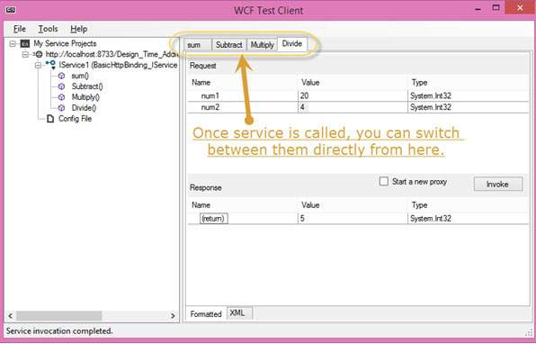

**RESULT:**

Thus, the development of OGSA (open grid service architecture)compliant web service was executed successfully.

|  |  |
| --- | --- |
| **EX.NO: 09** | **PROCEDURE TO INSTALL STORAGE CONTROLLER AND INTERACT WITH IT** |
| **DATE:** |

**AIM:**

To find procedure to install storage controller and interact with it.

**PROCEDURE:**

OpenStack Object Storage (swift) is used for redundant, scalable data storage using clusters of standardized servers to store petabytes of accessible data. It is a long-term storage system for large amounts of static data which can be retrieved and updated.

OpenStack Object Storage provides a distributed, API-accessible storage platform that can be integrated directly into an application or used to store any type of file, including VM images, backups, archives, or media files. In the OpenStack dashboard, you can only manage containers and objects.

In OpenStack Object Storage, containers provide storage for objects in a manner similar to a Windows folder or Linux file directory, though they cannot be nested. An object in OpenStack consists of the file to be stored in the container and any accompanying metadata.

**Create a container**

* + - 1. Log in to the dashboard as user

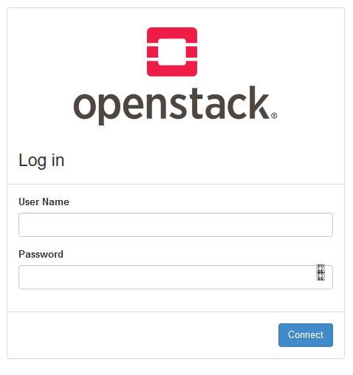

1. Select the appropriate project from the drop down menu at the top left.

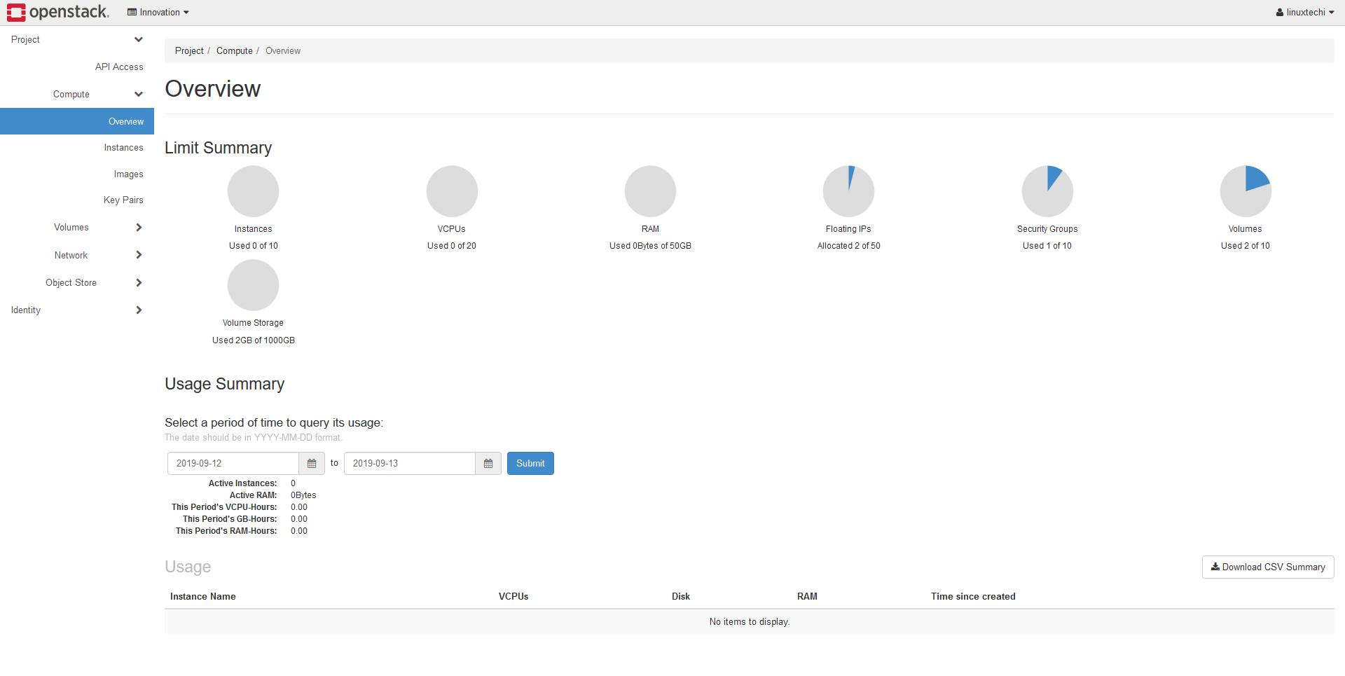

1. On the Project tab, open the Object Store tab and click Containers category.
2. Click Container.

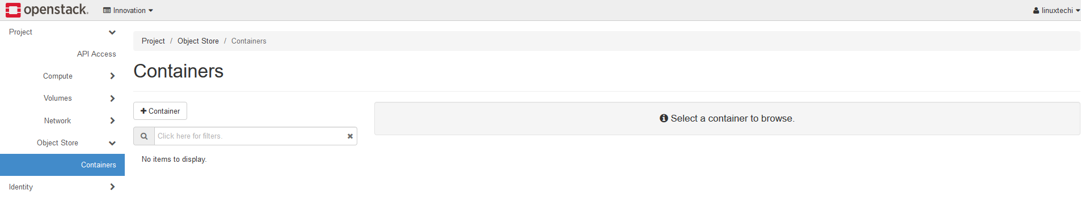

1. In the Create Container dialog box, enter a name for the container, and then click Create.

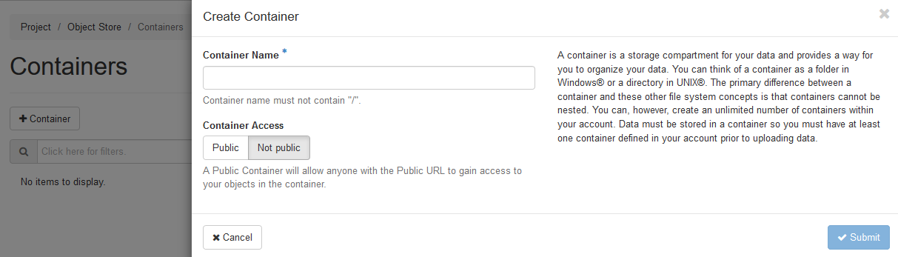

Name:mylinux1

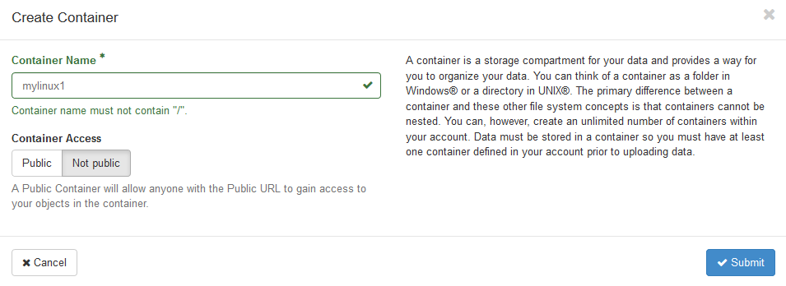

You have successfully created a container.

**Upload an object**

1. Log in to the dashboard as user.
2. Select the appropriate project from the drop down menu at the top left.
3. On the Project tab, open the Object Store tab and click Containers category.
4. Select the container in which you want to store your object.
5. Click the Upload File icon.

The Upload File To Container: <name> dialog box appears. <name> is the name of the container to which you are uploading the object.

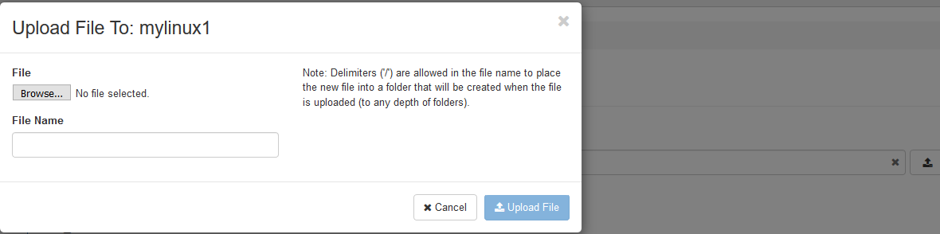

1. Enter a name for the object.

Name: Fest event gallery

1. Browse to and select the file that you want to upload.
2. Click Upload File.

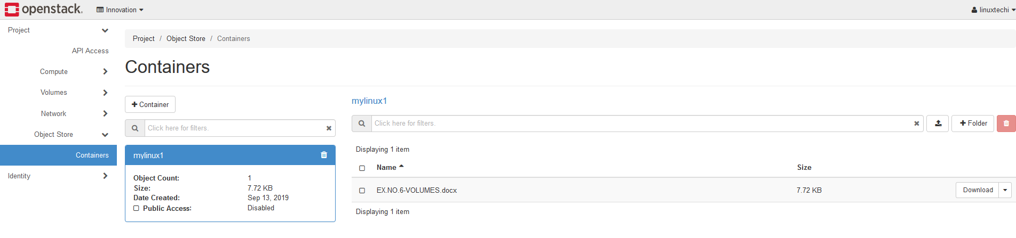

You have successfully uploaded an object to the container.

**Manage an object**

**To edit an object**

1. Log in to the dashboard as user.
2. Select the appropriate project from the drop down menu at the top left.
3. On the Project tab, open the Object Store tab and click Containers category.
4. Select the container in which you want to store your object.
5. Click the menu button and choose Edit from the dropdown list.

The Edit Object dialog box is displayed.

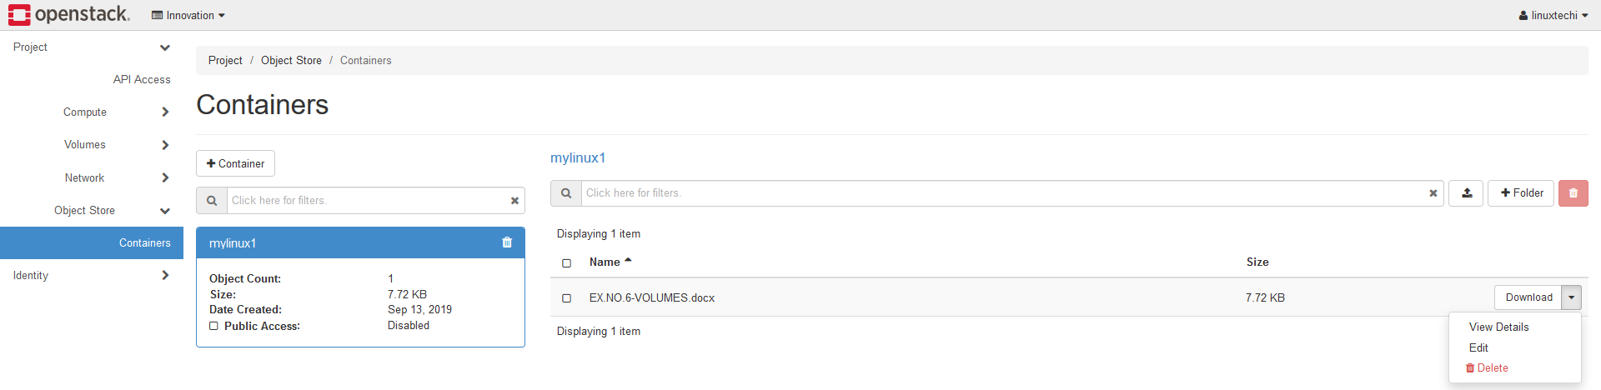

1. Browse to and select the file that you want to upload.

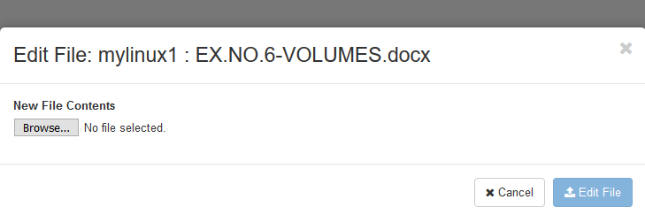

1. Click Update Object.

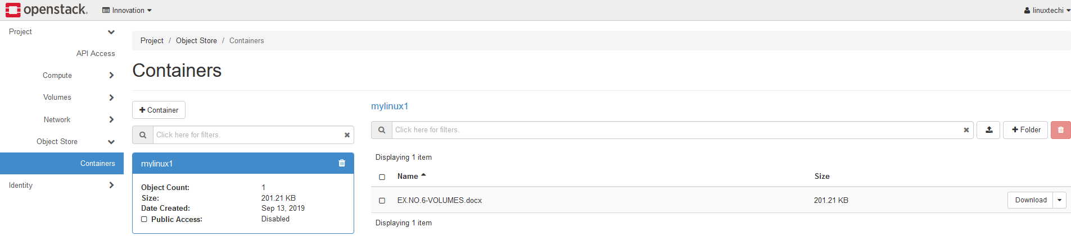

**RESULT:**

Thus, the procedure to install storage controller and interact with it has been studied and verified successfully.

**VIVA QUESTIONS:**

1. **What is DES?**

DES is the Data Encryption Standard, an encryption block cipher defined and endorsed by the U.S. government in 1977 as an official standard; the details can be found in the latest official FIPS (Federal Information Processing Standards) publication concerning DES.

1. **What is Diffie-Hellman?**

It is a method by which a key can be securely shared by two users without any actual exchange.

1. **What is RSA algorithm?**

RSA is short for Rivest-Shamir-Adleman algorithm. It is the most commonly used public key encryption algorithm in use today.

1. **How do you use RSA for both authentication and secrecy?**

RSA is a public key encryption algorithm. The RSA algorithms are based on the mathematical part that it is easy to find and multiply large prime numbers together, but it is extremely difficult to factor their product. For authentication: One can encrypt the hash (MD4/SHA) of the data with a private key. This is known as digital signature. For Secrecy: Secrecy/confidentiality is achieved by encrypting the data with public key and decrypting with private key.

1. **What is SHA-1?**

SHA is a secure hash algorithm developed by National Institute of Standard technology SHA-1 is a type of SHA message digest size of SHA 1 Is 160 bits and message size is < 2^64 it uses block cipher.

**VIVA QUESTIONS:**

1. **What is the difference between DSA and RSA?**

DSA means Digital Signature Algorithm. The basic difference between DAS and RSA is RSA can encrypt and sign, however DSA is only used for digital signature.

1. **What is Digital Signatures?**

Digital signature is an attachment to an electronic message used for security purpose. It is used to verify the authenticity of the sender.

1. **What is message authentication?**

When the verifier validates the digital signature using public key of a sender, he is assured that signature has been created only by sender who possess the corresponding secret private key and no one else.

1. **What are the services provided by digital certificates?**

Digital certificate provide authentication, nonrepudiation and integrity services.